**DAILY ONLINE ACTIVITIES SUMMARY**

|  |  |  |  |  |  |  |  |  |
| --- | --- | --- | --- | --- | --- | --- | --- | --- |
| **Date:** | **14/7/2020** | | | | | **Name:** | **Apoorva U** | |
| **Sem & Sec** | **8th Sem** | | | | | **USN:** | **4AL16CS017** | |
| **Online Test Summary** | | | | | | | | |
| **Subject** | | **-----** | | | | | | |
| **Max. Marks** | | **----** | | **Score** | | | **-----** | |
| **Certification Course Summary** | | | | | | | | |
| **Course** | **Introduction to SQL** | | | | | | | |
| **Certificate Provider** | | | **Datacamp** | | **Duration** | | | **4hrs** |
| **Coding Challenges** | | | | | | | | |
| **Problem Statement:**  Java program to print hollow mirrored Rhombus | | | | | | | | |
| **Status:COMPLETED** | | | | | | | | |
| **Uploaded the report in Github** | | | | | **yes** | | | |
| **If yes Repository name** | | | | | **Apoorva_u** | | | |
| **Uploaded the report in slack** | | | | | **yes** | | | |

Online Test Details: (Attach the snapshot and briefly write the report for the same)

Certification Course Details: (Attach the snapshot and briefly write the report for the same)

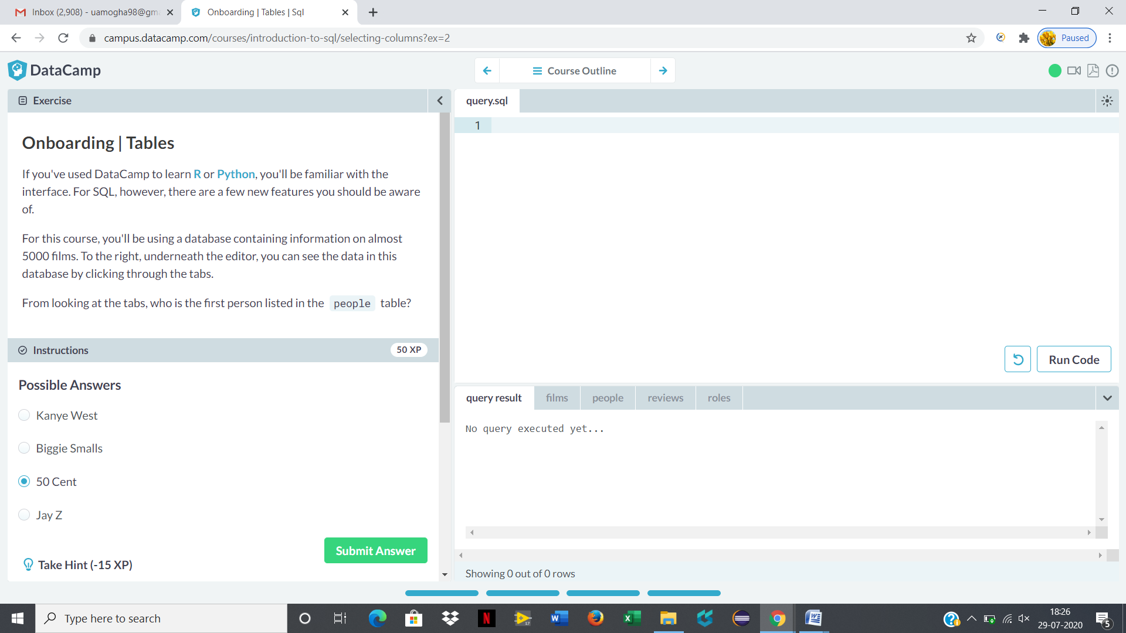

Coding Challenges Details: (Attach the snapshot and briefly write the report for the same)